# Adding Copy Express Product Pricing in OnPrintShop

1. **Click products on the left side of the admin control panel**

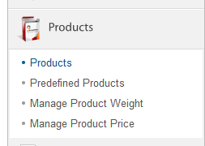

1. **Click Add Product**

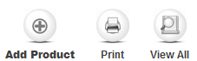

1. **Fill in the product details**

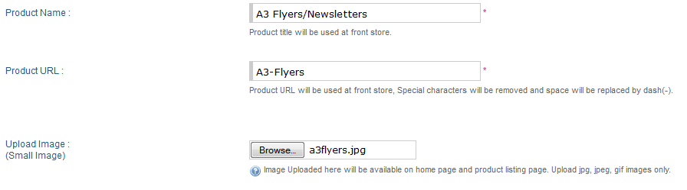

1. **You can add a description and an image for a product. Images are uploaded in the /images directory on the server**

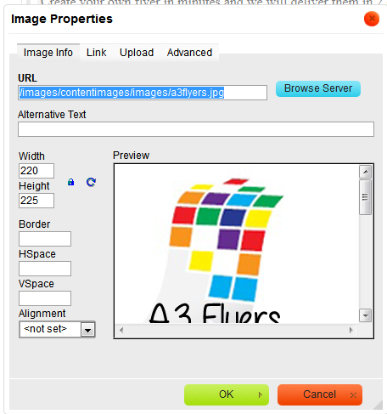

1. **Set up the price defining method and User Type**

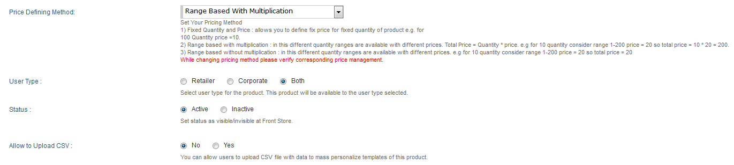

|  |  |
| --- | --- |
|  | *Set Your Pricing Method  1) Fixed Quantity and Price : allows you to define fix price for fixed quantity of product e.g. for  100 Quantity price =10.  2) Range based with multiplication : in this different quantity ranges are available with different prices. Total Price = Quantity * price. e.g for 10 quantity consider range 1-200 price = 20 so total price = 10 * 20 = 200. 3) Range based without multiplication : in this different quantity ranges are available with different prices. e.g for 10 quantity consider range 1-200 price = 20 so total price = 20* |

You can also specify the product availability for each user type (Retailer, Corporate or both)

1. **Product Size and Margin settings for the Design Studio**

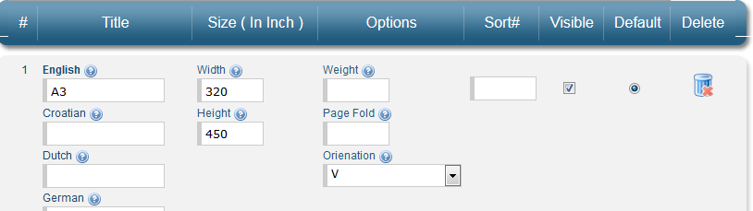

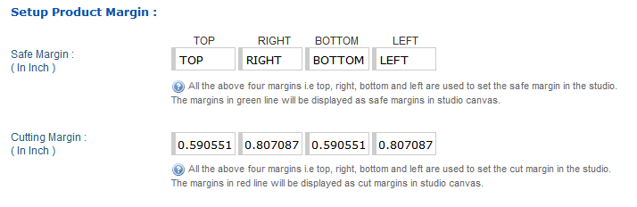

*Dimensions are in inches*

1. **Set up the Price for Retail Customers**

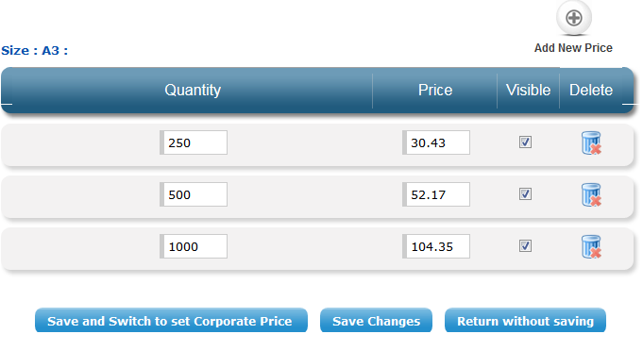

1. **Set up the Price for Corporate Customers.**

You can choose to set a price for a specific Corporate or a Common Price for All Corporate Customers. If you want a specific corporate customer to have a discount you have to calculate the discounted price and set the prices for the product in here.

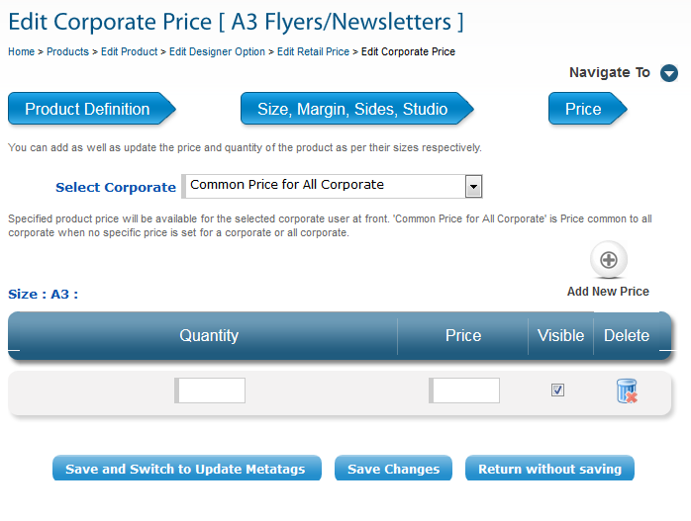

1. **Edit Metatags for the Browser**

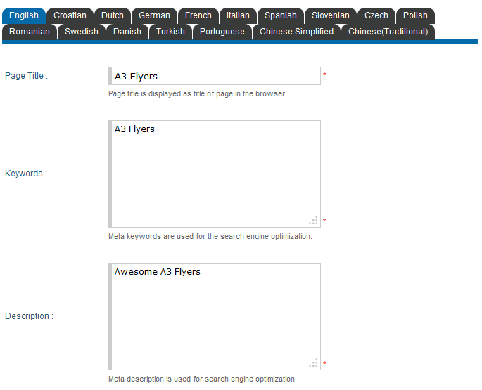

1. **Add Additional Options**

You can add additional options for a product e.g. Colour, Paper Size, Lamination, Rounded Corners etc

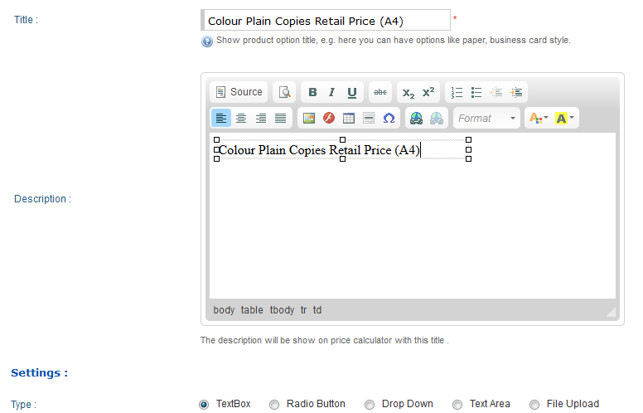

**Additional Option Display Type:**

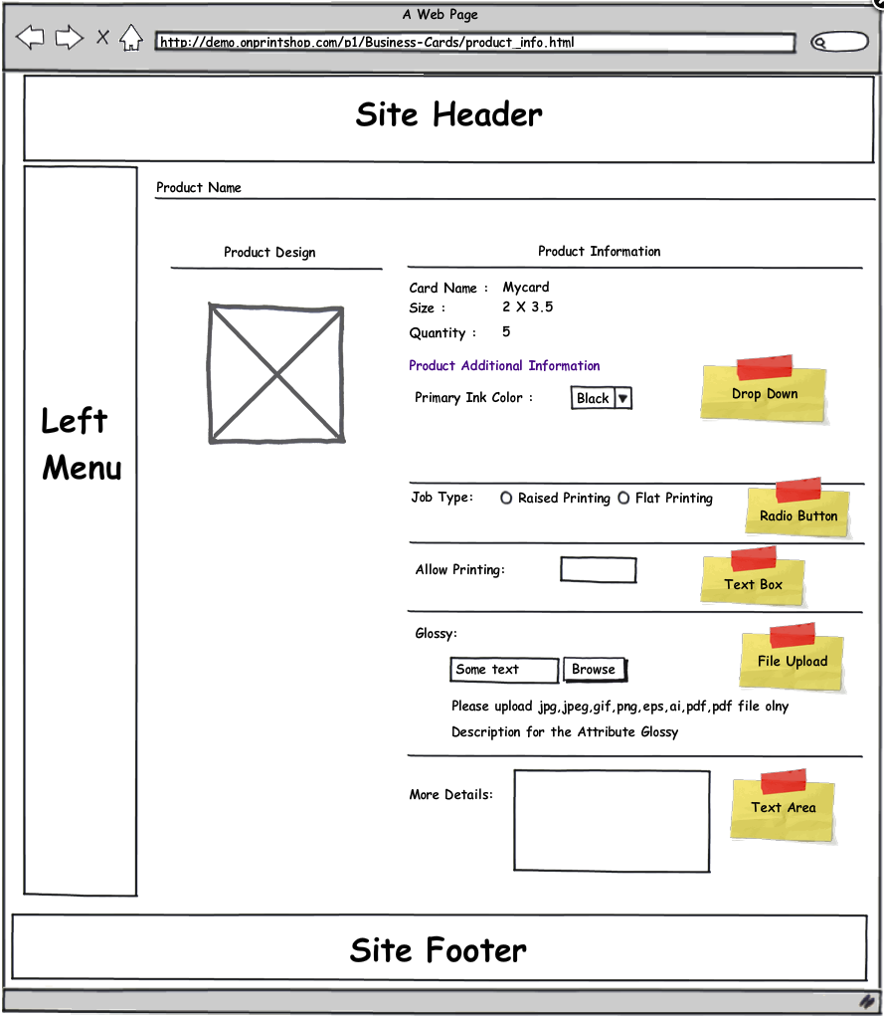

**Additional Option Name Position:**

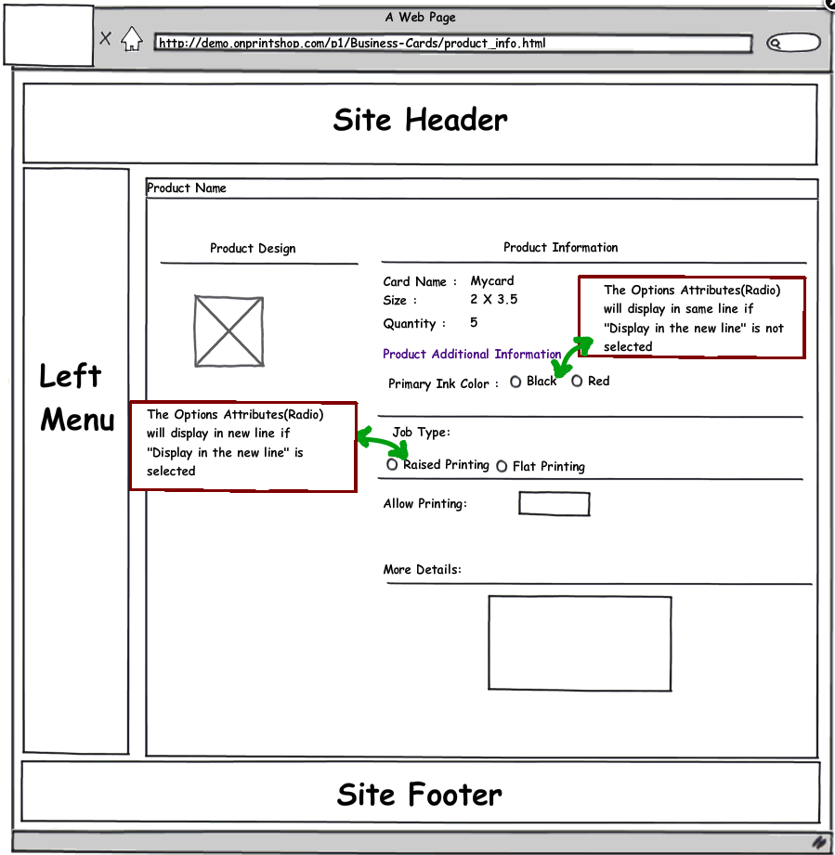

Additional Option Description Position

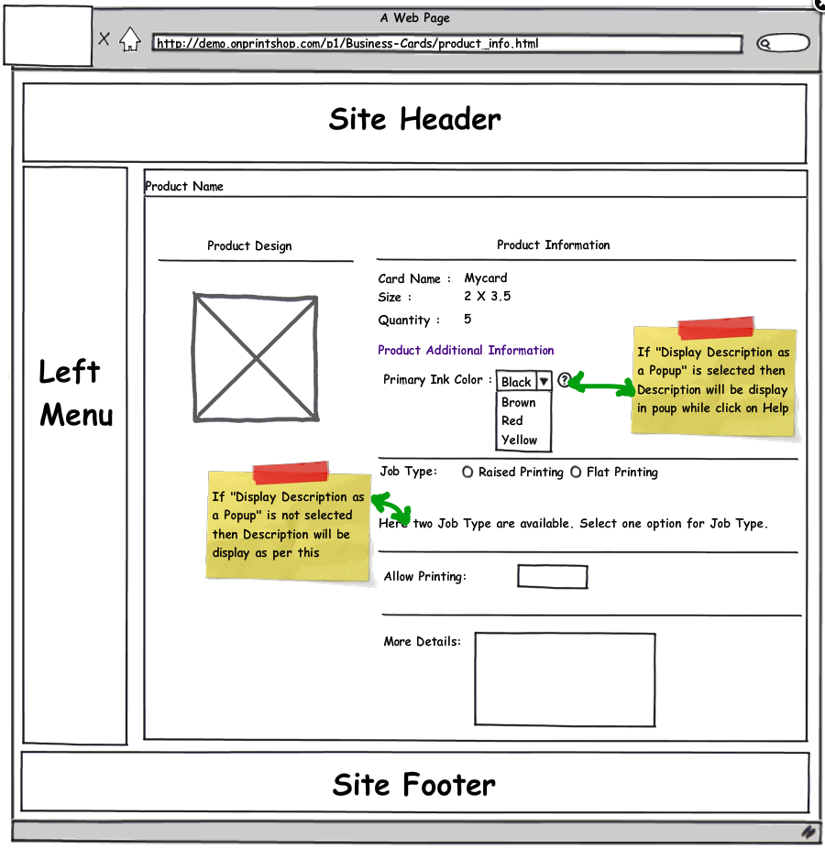

1. **Edit Additional Options Price**

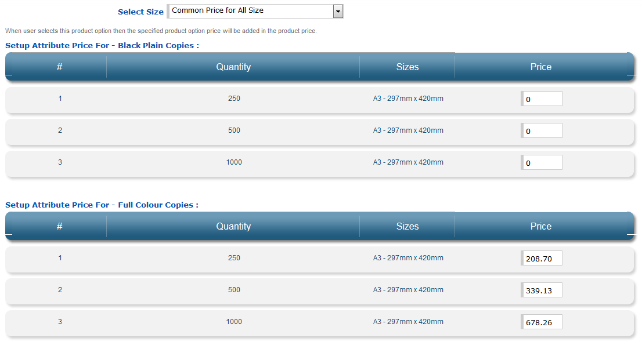You can set prices for each additional option. The prices are a surcharge to the price from Step 7.

1. **Add Rules for Additional Options**

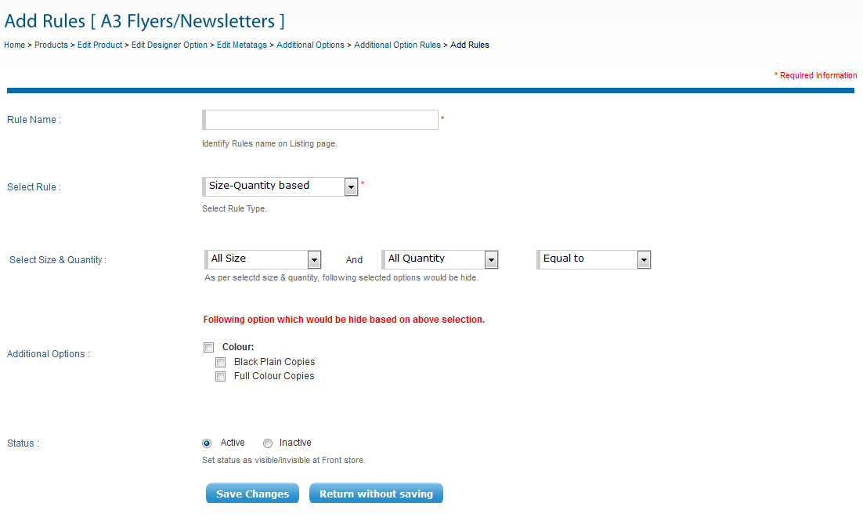

You can create Rules to hide Additional Options based on Quantity of an order or the Options selected. E.g. If the quantity is below 200, then hide the “Folded (90x110mm)” option.

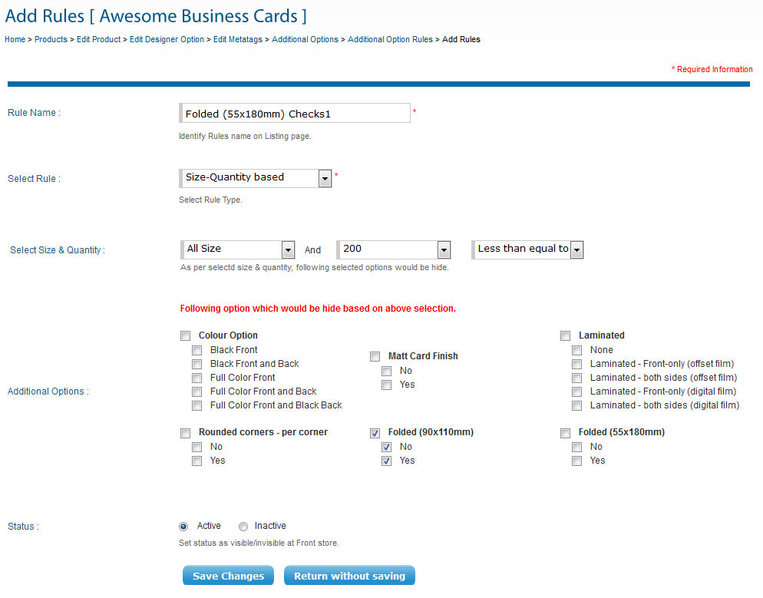

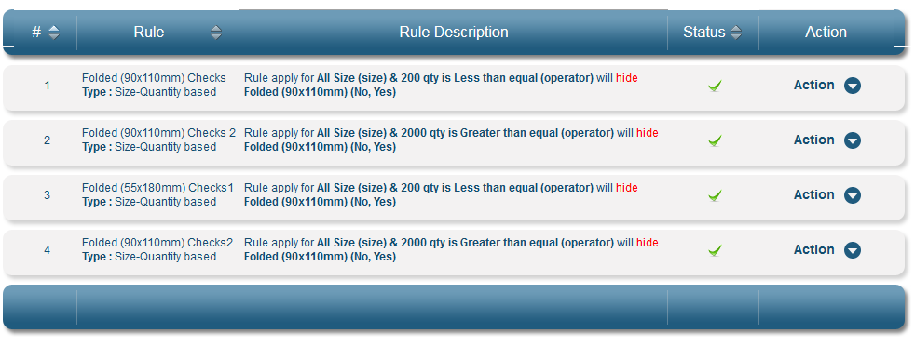

<http://salesdemo.onprintshop.com/en/awesome-cards/>

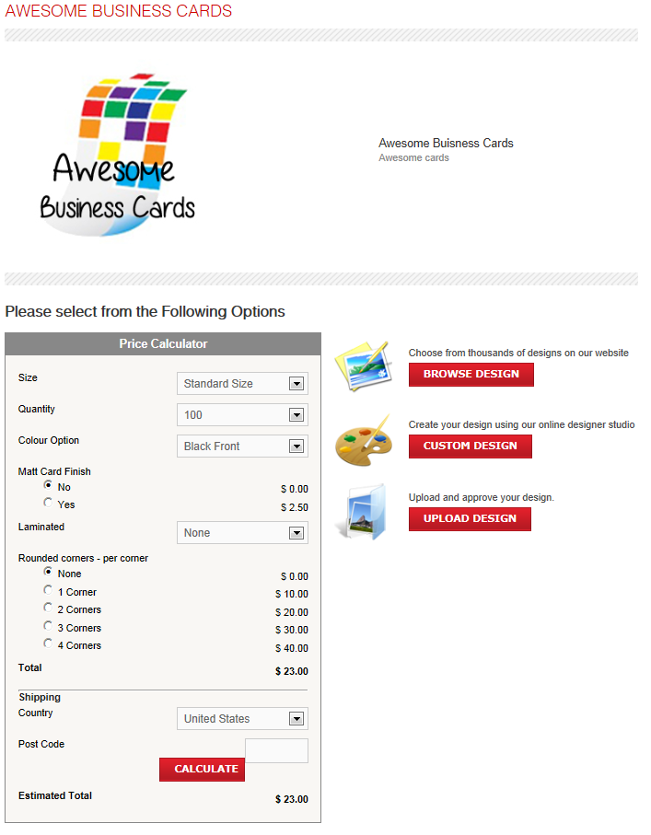

Folding options are only shown when the quantity selected is between 500 and 1000, and you can only select one folding option.

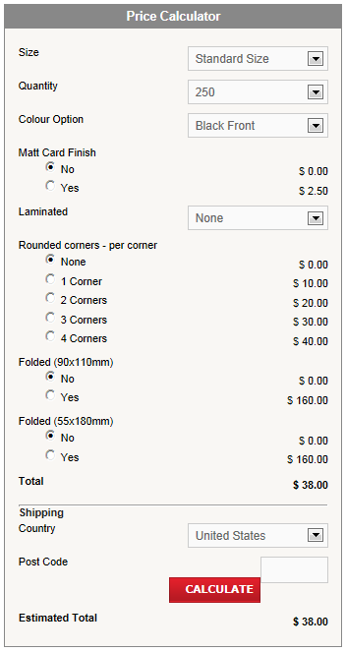

There are 5 corner options available and when the 1, 2, 3 radio box are ticked then a new dropdown option is displayed below it. Clicking on the help icon will display a help window which displays the different options for each number of corner selected.

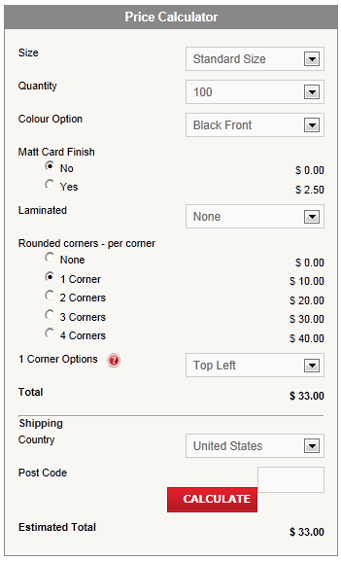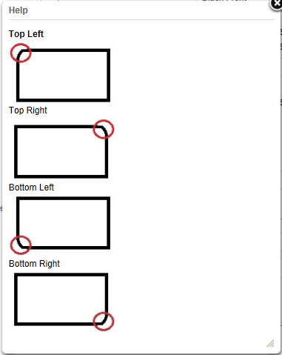

The help window can be edited in the product creation and can include